Testing the website

# The homepage (index.html):

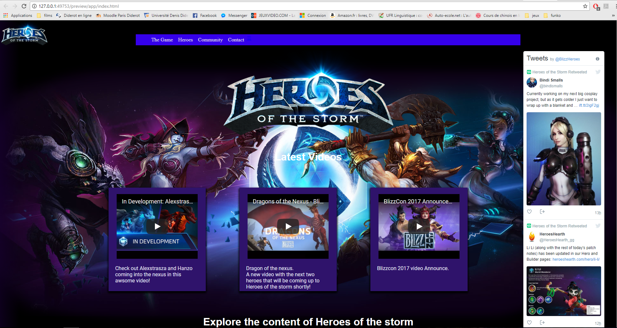

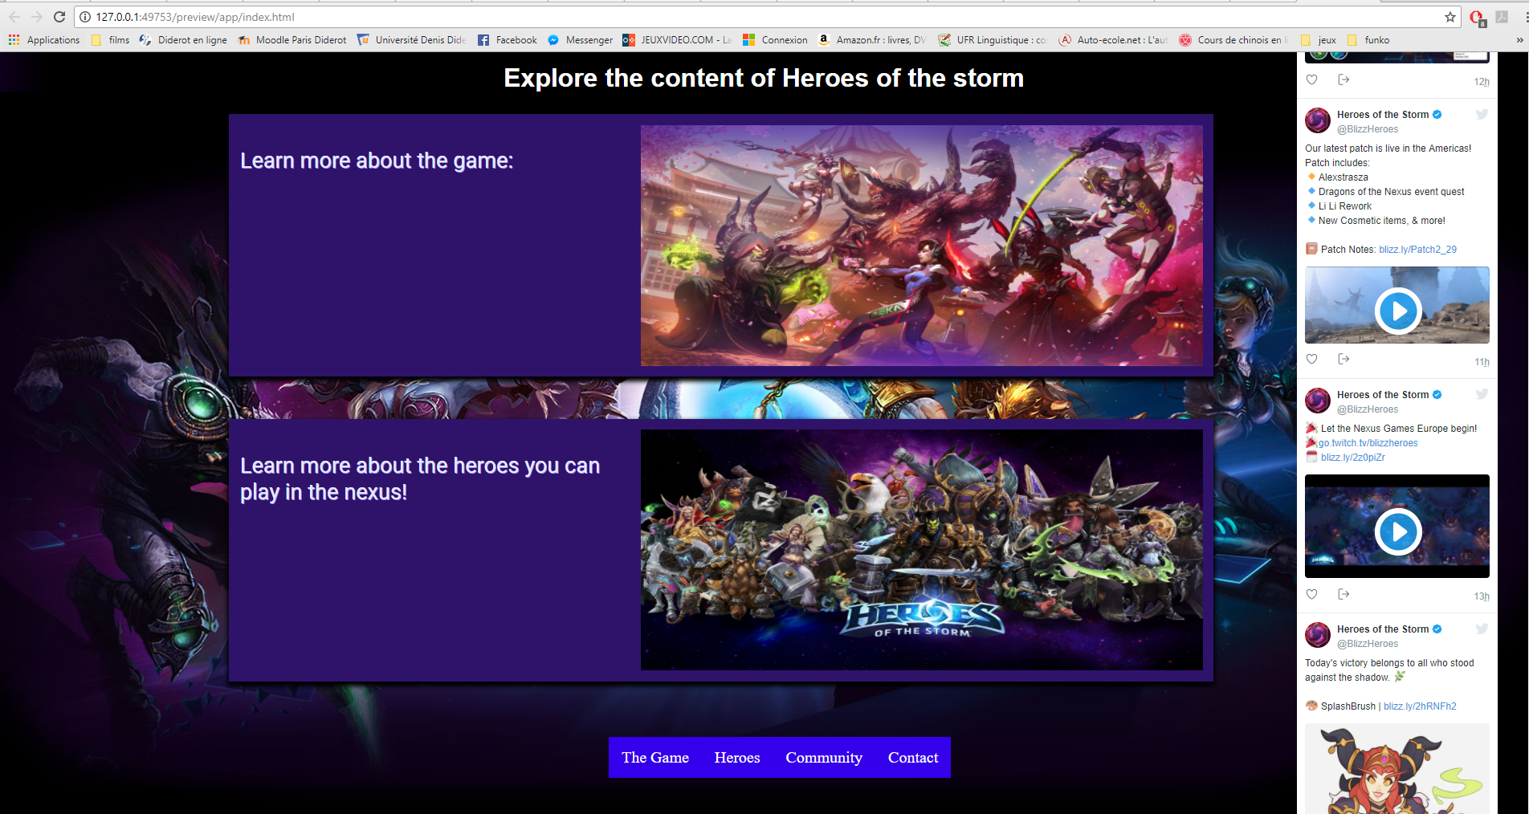

|  |  |  |  |
| --- | --- | --- | --- |
| Home Page | How tested / data | Expected result | Actual result |
| When the user click any hyperlink in the navbar. | Click on “The Game”, “Heroes”, ”Community” or “Contact” | Each page must be displayed | ✓ |
| When the user click on a video | Click on a video. | The video must be played | ✓ |
| When the user click on “Learn more about the game” | Click on the article | It must take the user to the page “theGame.html” | ✓ |
| When the user click on “Learn more about the heroes” | Click on the article | It must take the user to the page “heroes.html” | ✓ |
| When the user click any hyperlink in the navbar at the bottom. | Click on “The Game”, “Heroes”, ”Community” or “Contact” | Each page must be displayed | ✓ |
| When the user use the twitter’s widget | Click on a video in it / or click on links | Play the video or follow the links | ✓ |
| When the user resize the window | Resize the window | The twitter’s widget must disappear and the card must be align vertically and then shrink. | ✓ |
| When the user pass his cursor on a card | Pass the cursor on it | The card must be lightning up. | ✓ |

## Overview.html page test:

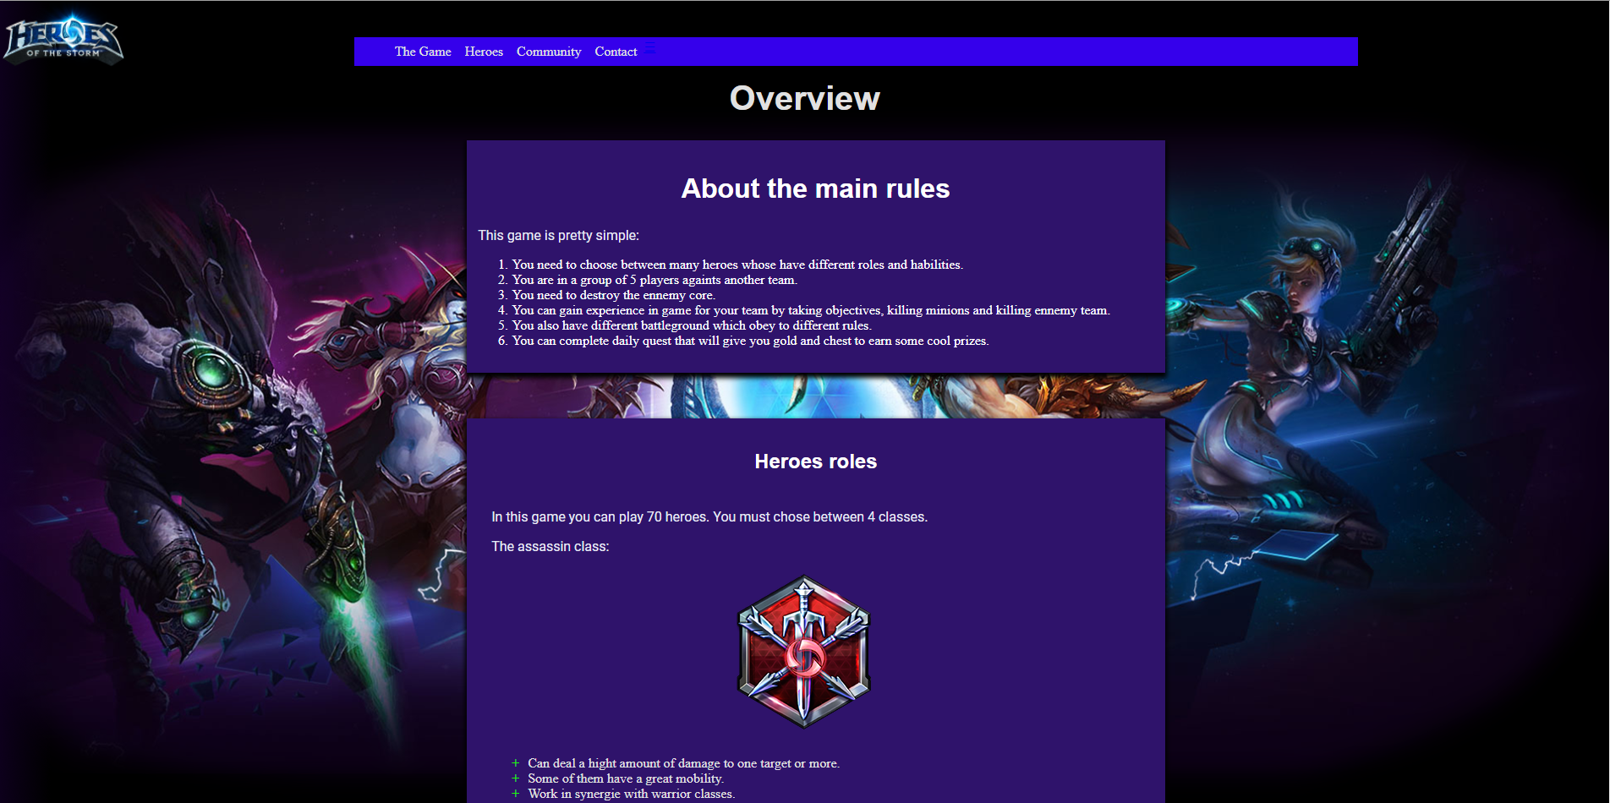

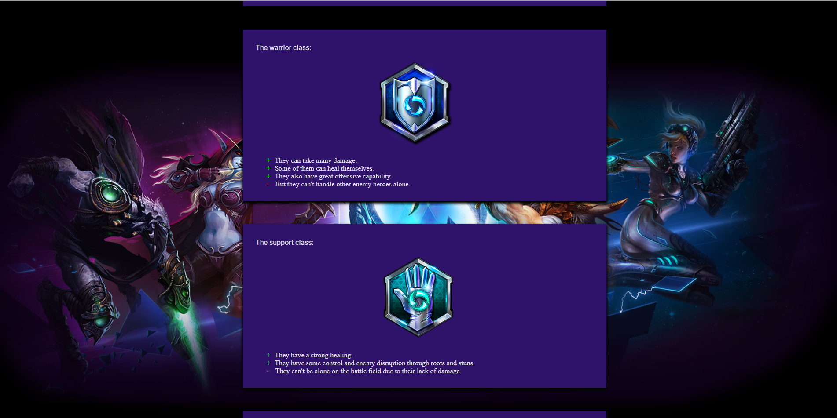

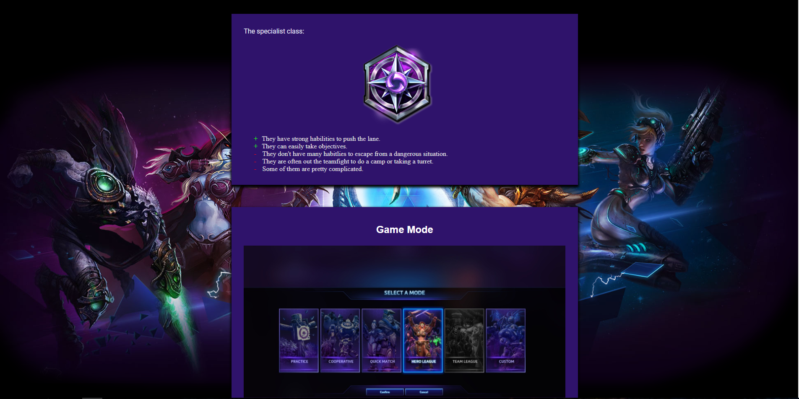

|  |  |  |  |
| --- | --- | --- | --- |
| Overview Page | How tested / data | Expected result | Actual result |
| When the user click any hyperlink in the navigation bar. | Click on “The Game”, “Heroes”, ”Community” or “Contact” | Each page must be displayed | ✓ |
| When the using is scrolling down. | Scrolling | The background image must stay static | ✓ |
| When the user resize the window | Resize the window | * The images inside the cards must disappear. * The card must be resized. * The navigation bar at the top must only be an icon. * The navigation bar at the bottom must disappear. | ✓ |
| When the user want to return to the Home page | Click on the logo | Return to the homepage | ✓ |

## Heroes.html page test:

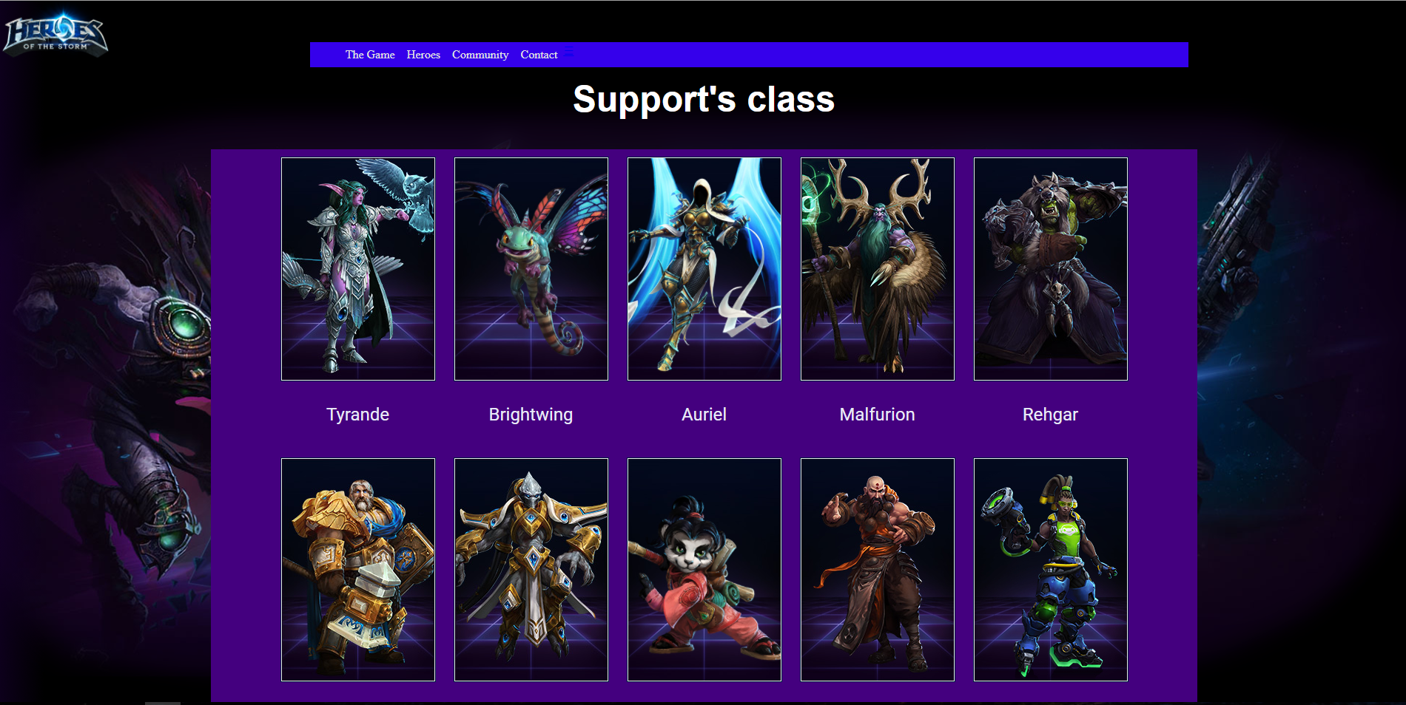

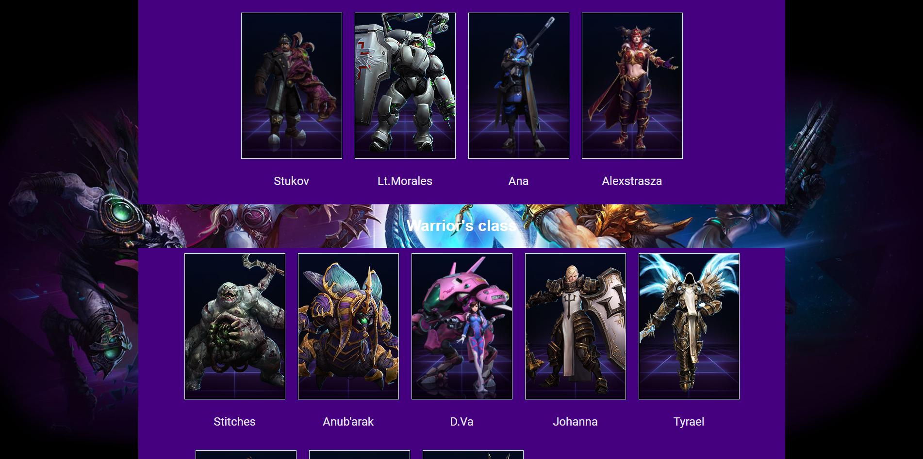

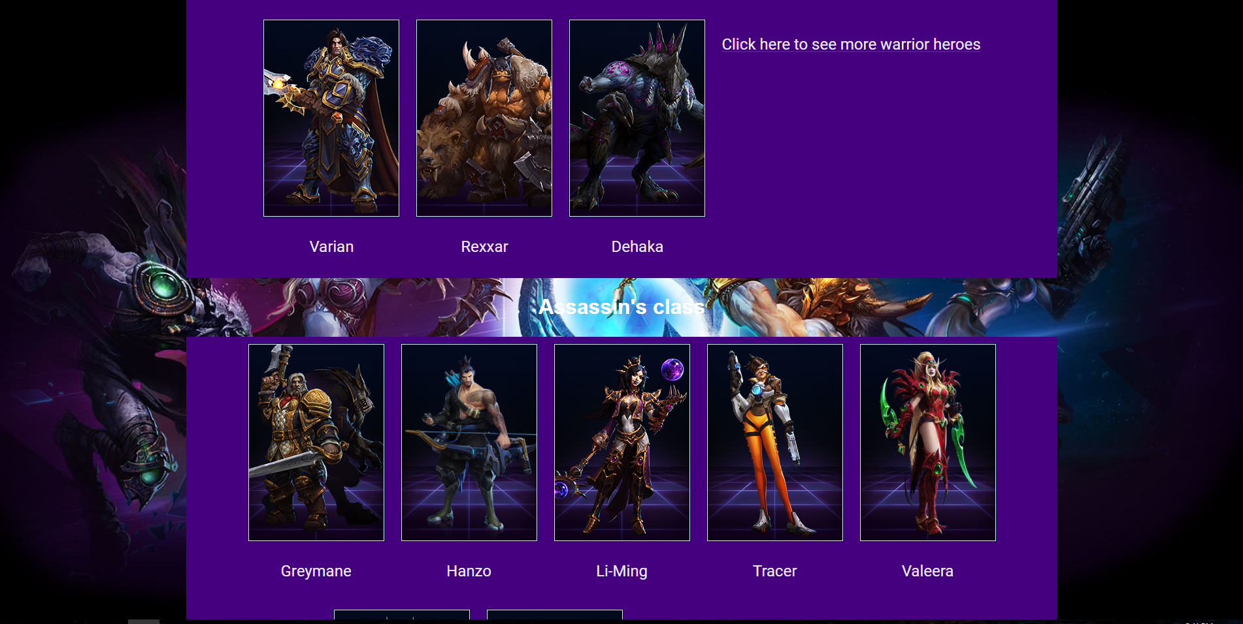

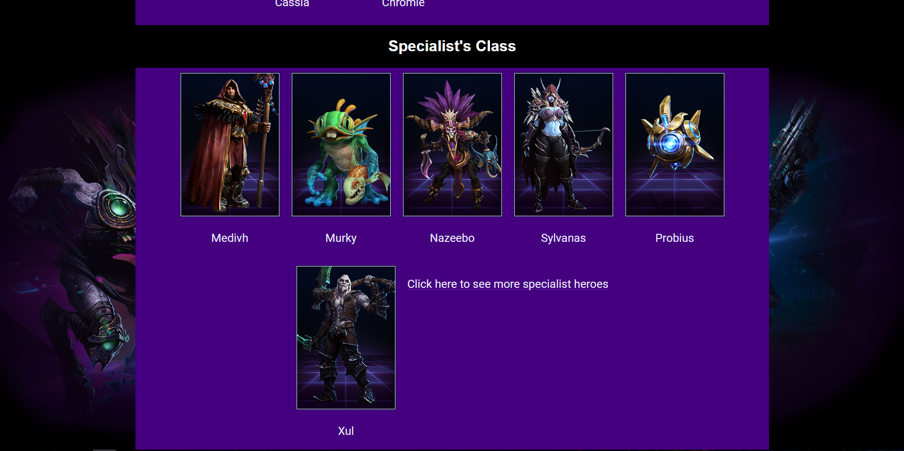

|  |  |  |  |
| --- | --- | --- | --- |
| Heroes Page | How tested / data | Expected result | Actual result |
| When the user click any hyperlink in the navigation bar. | Click on “The Game”, “Heroes”, ”Community” or “Contact” | Each page must be displayed | ✓ |
| When the using is scrolling down. | Scrolling | The background image must stay static | ✓ |
| When the user resize the window | Resize the window | * The images must be aligned vertically. * The card must be resized. * The navigation bar at the top must only be an icon. * The navigation bar at the bottom must disappear. | ✓ |
| When the user click on a character’s image | Click on a character’s image | Open a new tab and send us to the appropriate page. | ✓ |
| When the user click on “Click here to see…” | Click on the links | Open a new tab and send us to the appropriate page. | ✓ |
| When the user pass his cursor on an image | Pass the cursor on it | The image must be lightning up. | ✓ |
| When the user want to return to the Home page | Click on the logo | Return to the homepage | ✓ |

## Community.html page test:

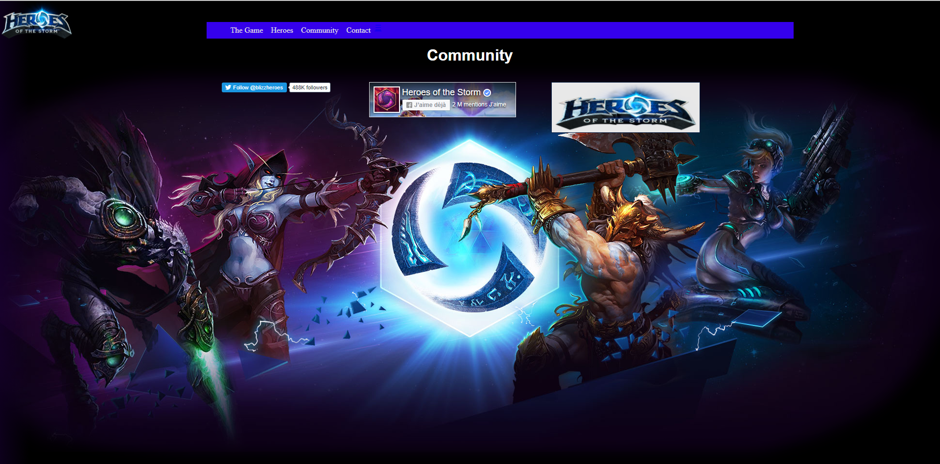

|  |  |  |  |
| --- | --- | --- | --- |
| Heroes Page | How tested / data | Expected result | Actual result |
| When the user click any hyperlink in the navigation bar. | Click on “The Game”, “Heroes”, ”Community” or “Contact” | Each page must be displayed | ✓ |
| When the user resize the window | Resize the window | * The image and widgets must be aligned vertically. * The navigation bar at the top must only be an icon. * The navigation bar at the bottom must disappear. | ✓ |
| When the user want to go to the twitter page | Click on the follow button | Must go on the twitter site | ✓ |
| When the user want to go to the Facebook page | Click on the thumb button | Must go on the Facebook site or add the “heroes of the storm” Facebook page to your favorites pages on Facebook | ✓ |
| When the user want to go on the official website of this game | Click on the logo button | Must go on the official page. | ✓ |
| When the user want to return to the Home page | Click on the logo | Return to the homepage | ✓ |

## Contact.html page test:

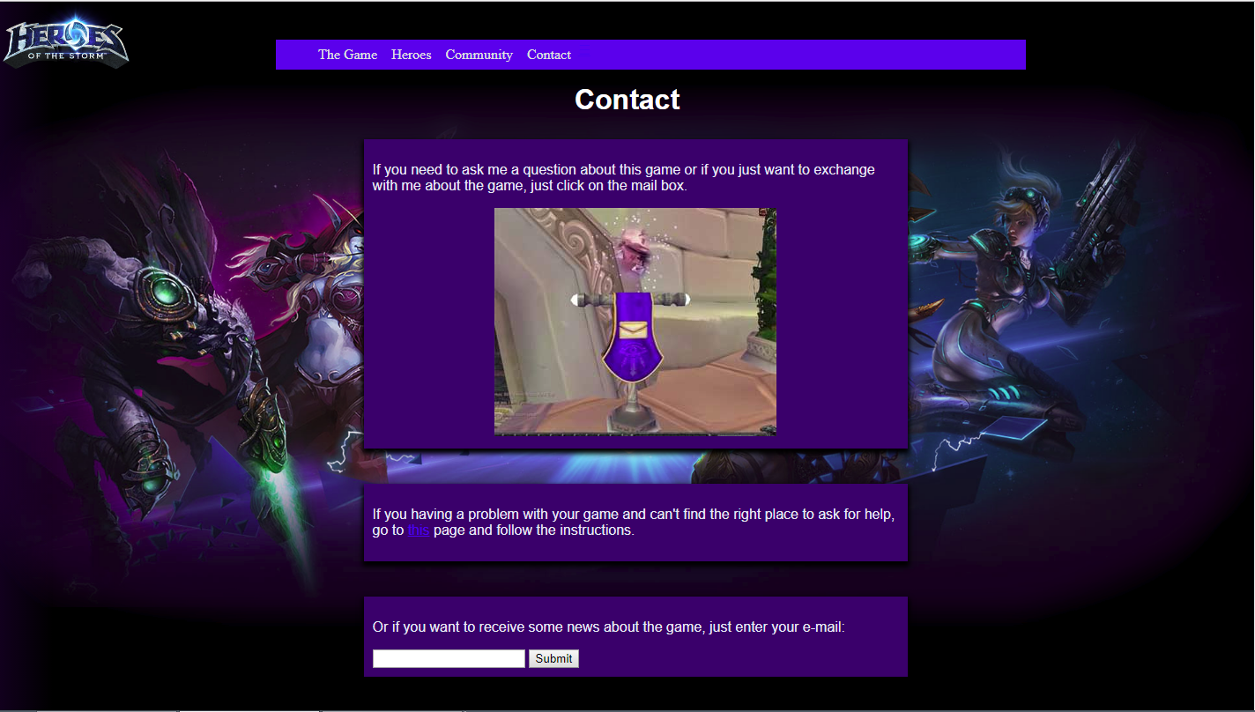

|  |  |  |  |
| --- | --- | --- | --- |
| Heroes Page | How tested / data | Expected result | Actual result |
| When the user click any hyperlink in the navigation bar. | Click on “The Game”, “Heroes”, ”Community” or “Contact” | Each page must be displayed | ✓ |
| When the user resize the window | Resize the window | * The card must be resized. * The navigation bar at the top must only be an icon. * The navigation bar at the bottom must disappear. | ✓ |
| When the user want to send an e-mail to me | Click on the mailbox image | Must open the mail box with my email inside the receiver and the subject “I have a question” | ✓ |
| When the user want to have some extra help in the original website | Click on the link “this” | Open in a new tab and display the appropriate website | ✓ |
| When the user want to submit his email | Enter an email and click on submit | Should display a message to notify the user that the email have been submitted to me. | 🗶 |
| When the user want to return to the Home page | Click on the logo | Return to the homepage | ✓ |

## W3C Validator:

### Index:

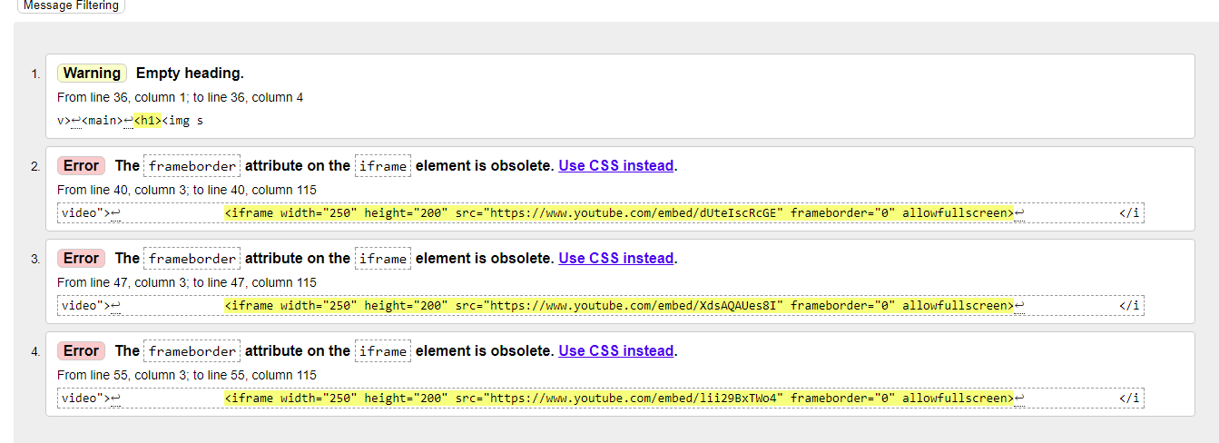

### Overview:



### Heroes:



### Community:



### Contact:

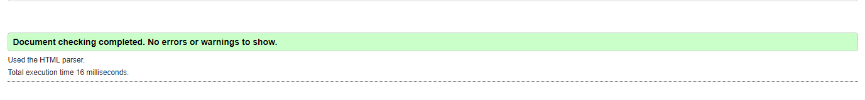

### CSS:

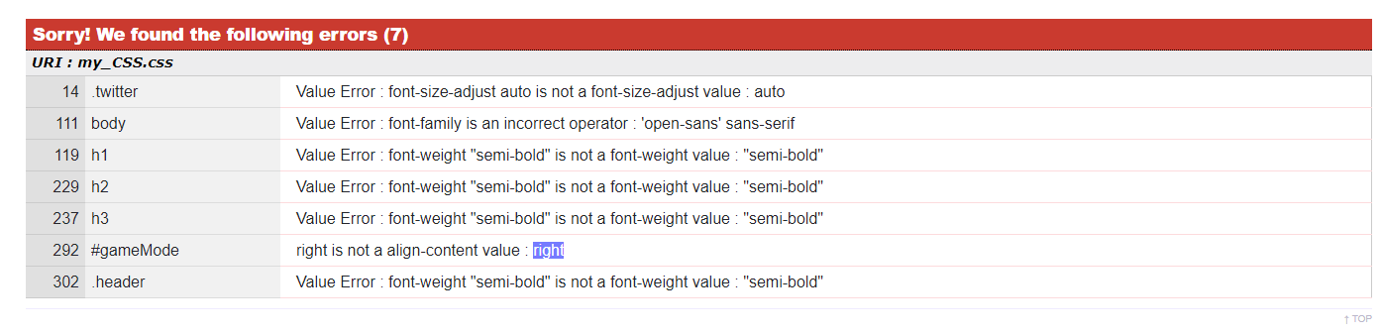

### 3. World wide web consortium

World Wide Web or W3C is about international standards for web sites. It is used for developing web site. It is also recommend to follow the standards but not obligated.

### 4. Proof of testing in other browsers

**Internet explorer:**

My background image is not displaying.

My icon from my media query for mobile is not hide.

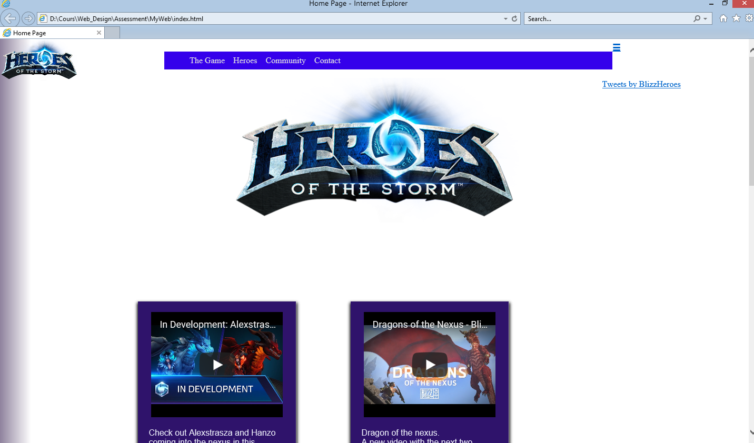

**Firefox:**

My icon from my media query for mobile is not hide.\

But the rest is good.

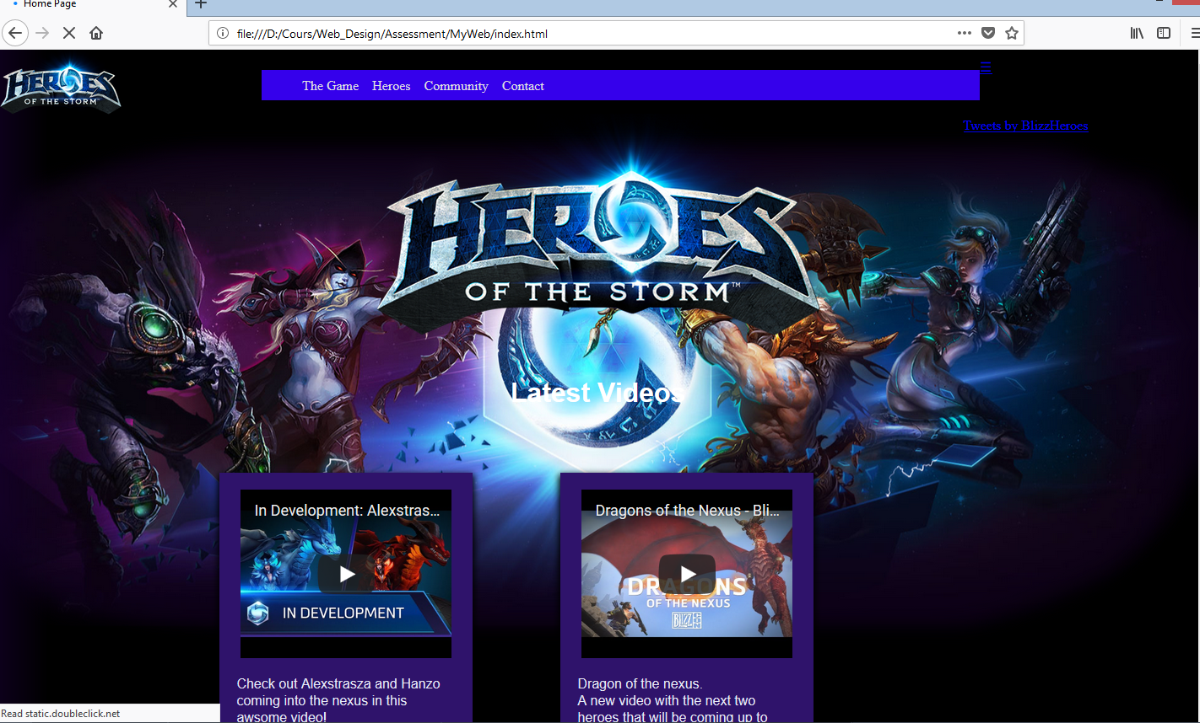

5. Future recommendation and enhancement

I would do a better navigation bar. And I would do a forum page  
 I would do a better responsive design.

## References

**Images:   
-** Background image: From Pinterest.  
- Images from my Heroes page: From <http://eu.battle.net/heroes/en/heroes>  
- Images from my Overview page: From google image.  
- Images from my Contact page: From google image.  
- Images from Community page: From google image.

Videos:

From youtube